Analysed DNS Log File Using Splunk SIEM
Introduction
In this report, DNS log file will be analysed using Splunk SIEM, an open source file from Github gist was used for the purpose of this task as seen below.

Downloaded dns log file on github gist for the purpose of this task.
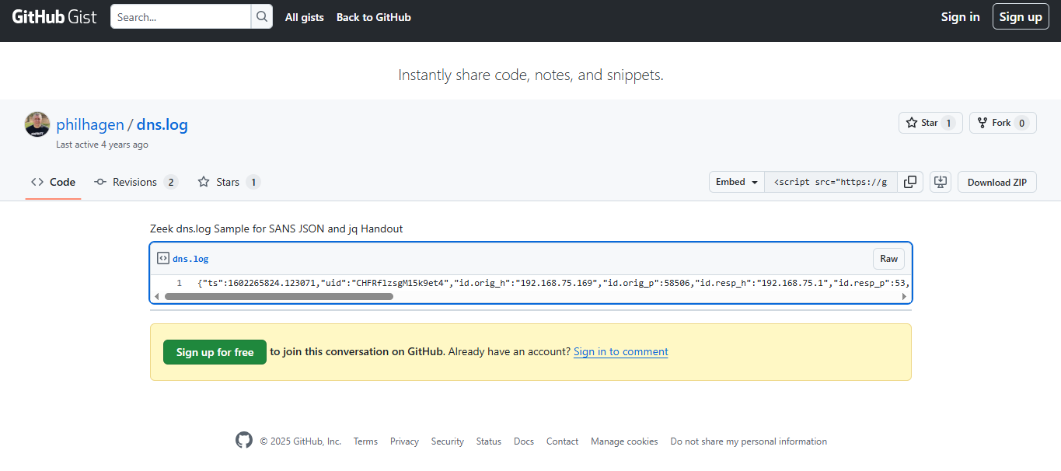
Log in to Splunk web interface and navigate to “Settings> Add Data

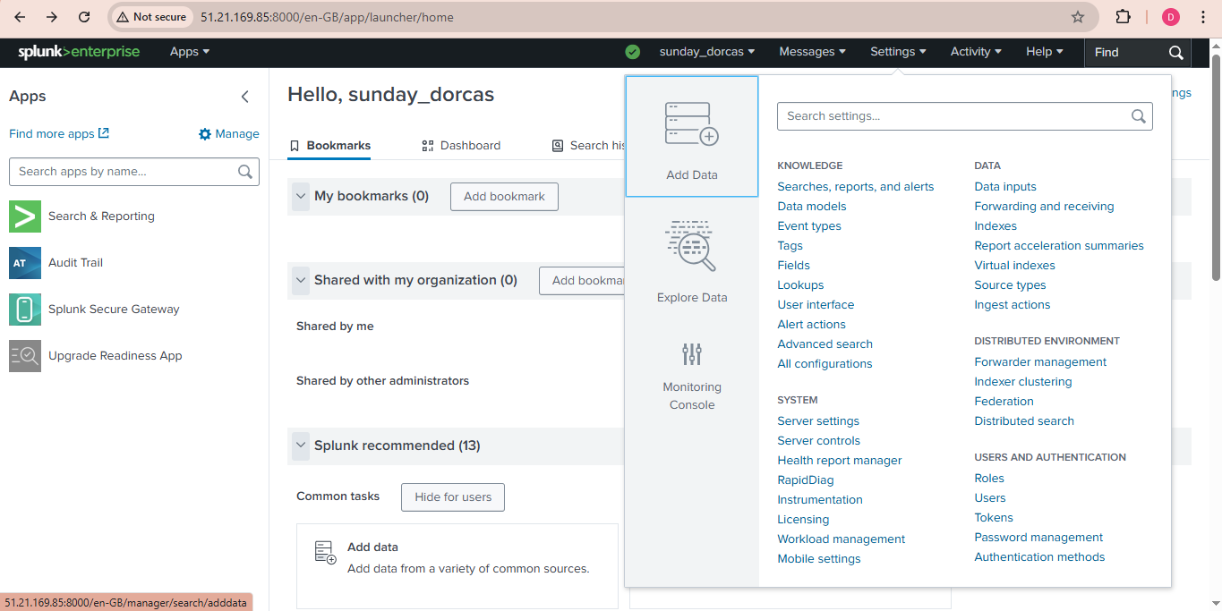
Select “Upload”
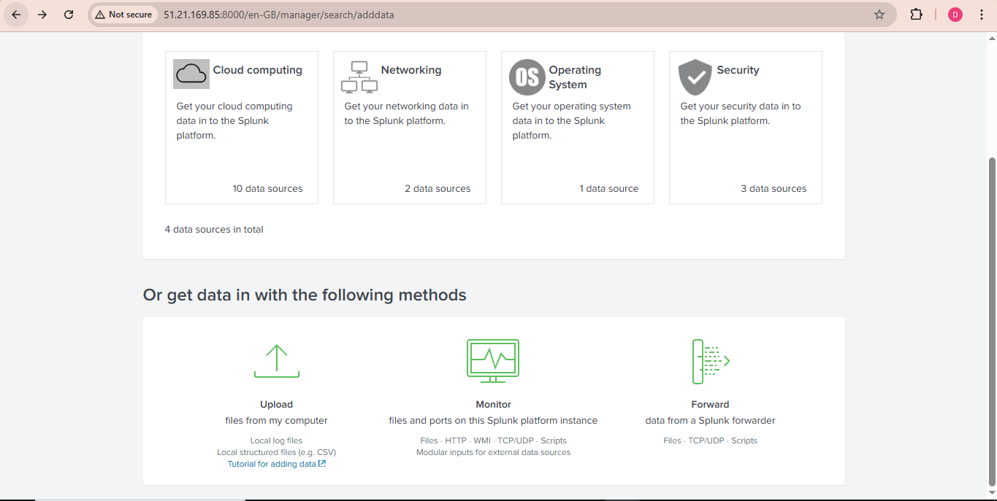

Click “Select File” and choose the sample DNS log file
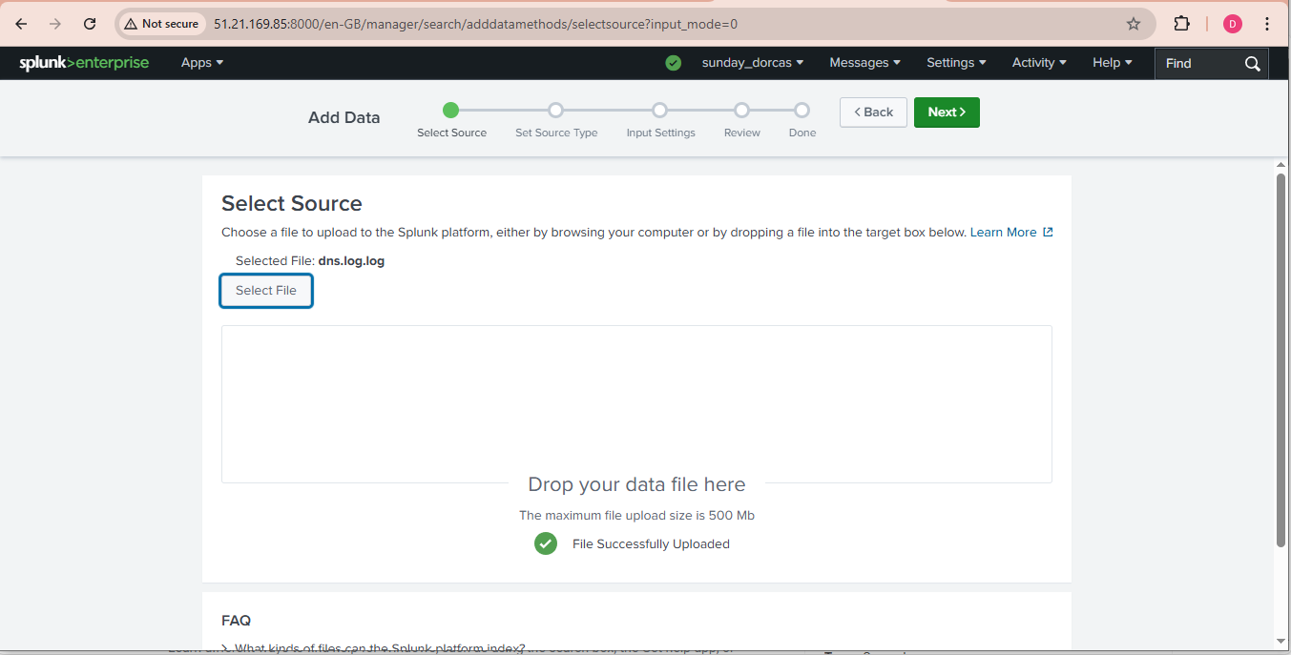
Click on next to select source type, indicate the source type for the uploaded log file.
Select the appropriate soruce type for DNS logs (e.g dnslog or any custom source type)
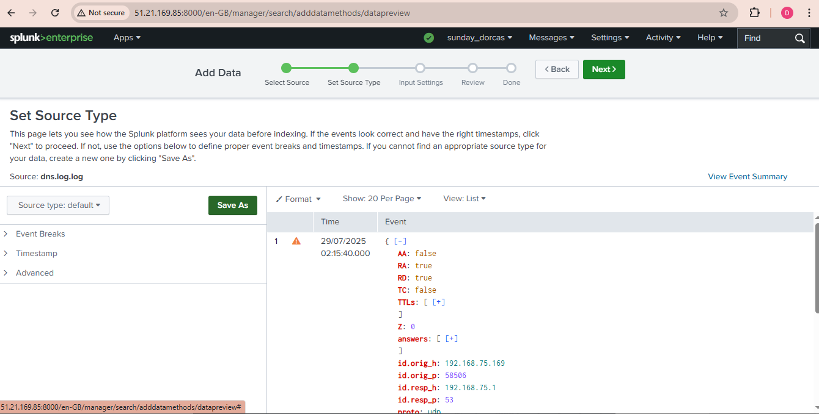

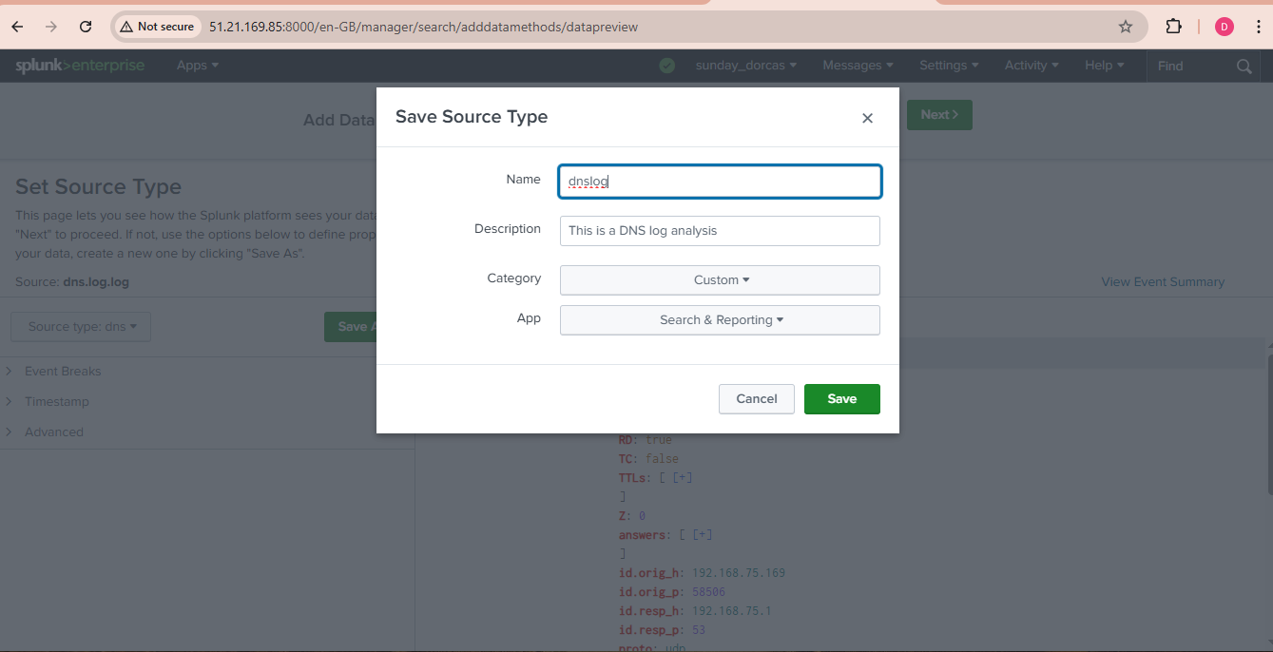

Review other settings such as host, index, and sourcetype and ensure the settings are configured properly.
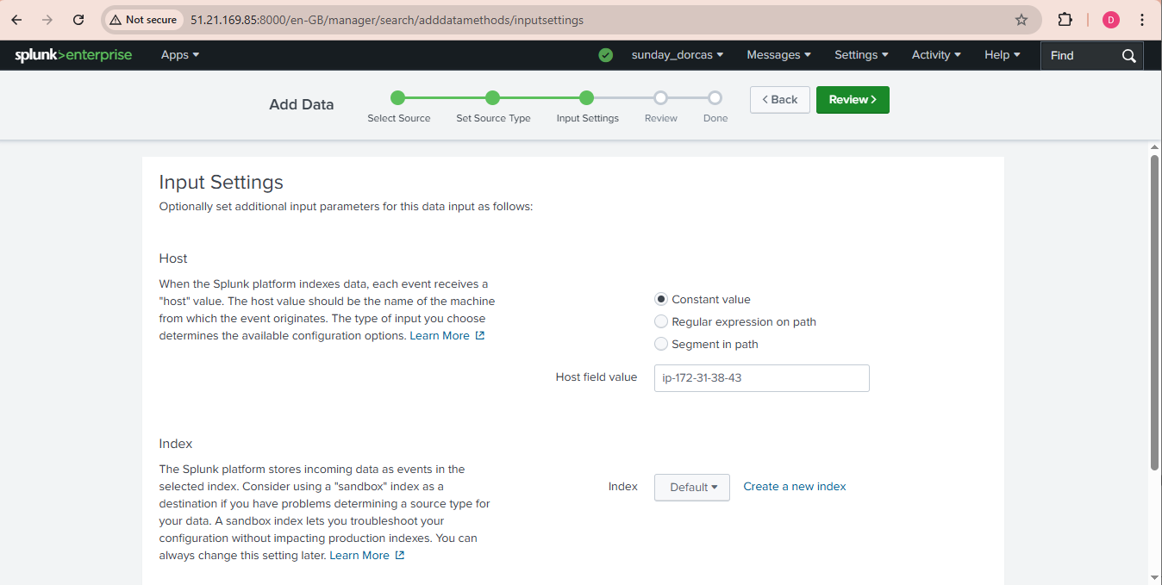
Click on “Review” button after the configuration and review the settings to ensure accuracy and click “Submit” to upload DNS log file to Splunk.
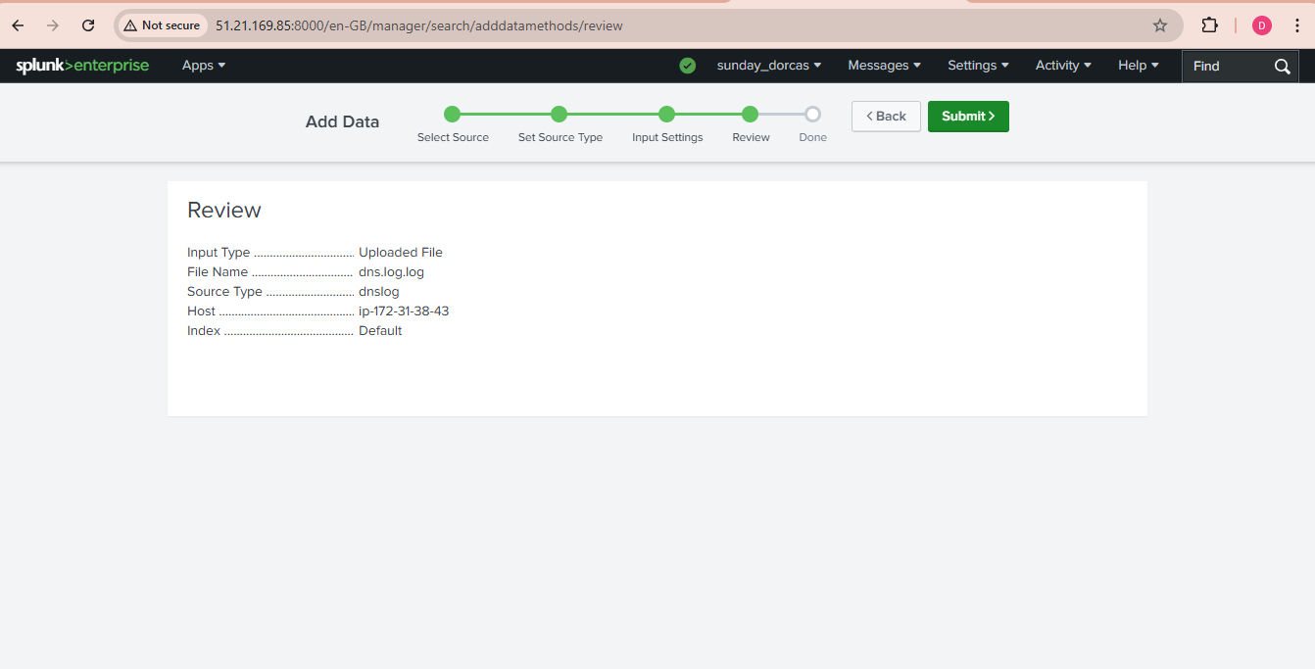
Navigate to search bar in the interface after uploading and run a search query to verify the DNS events are visible with this code index=<dns_index> sourcetype=<dns_sourcetype>

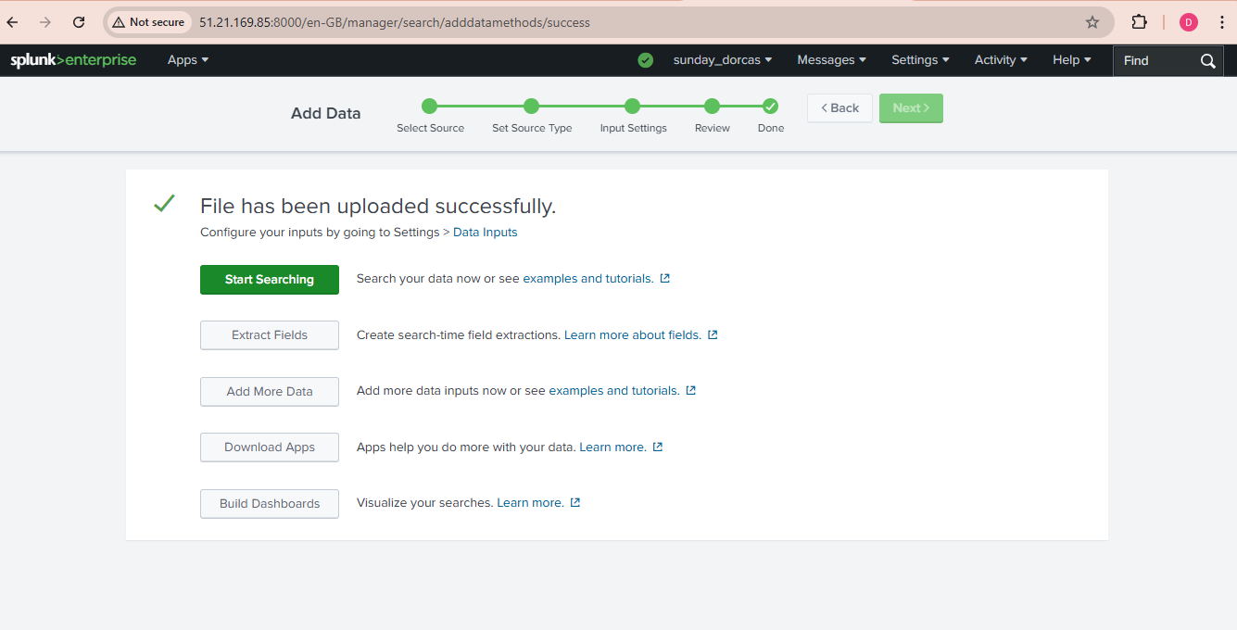

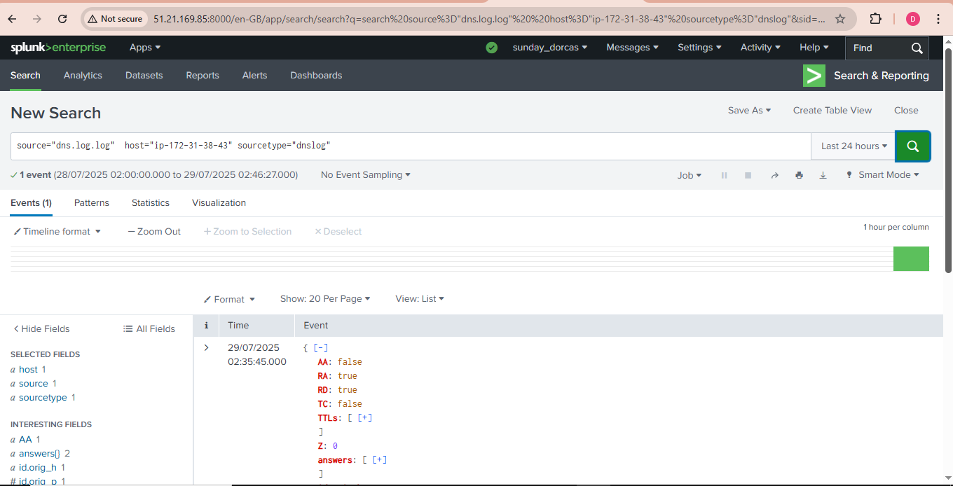

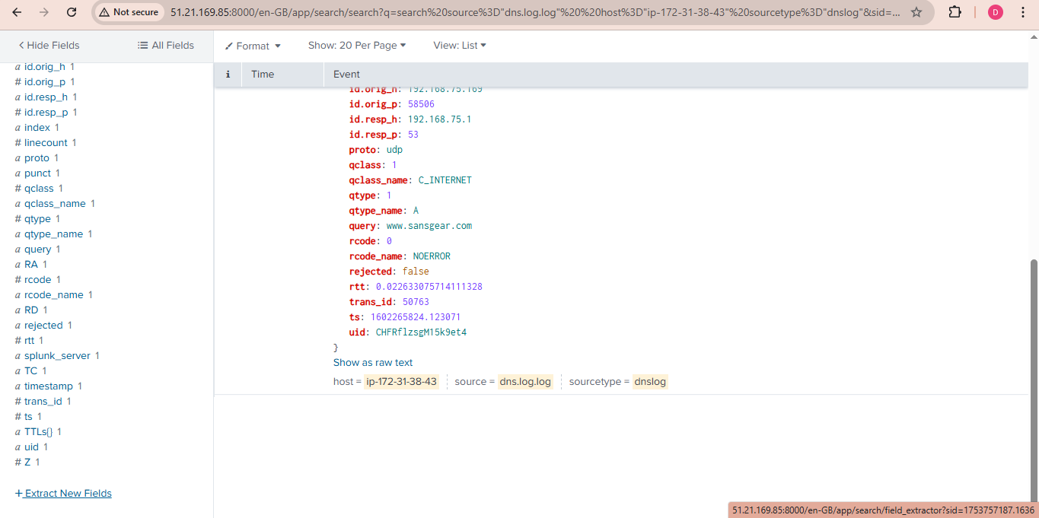

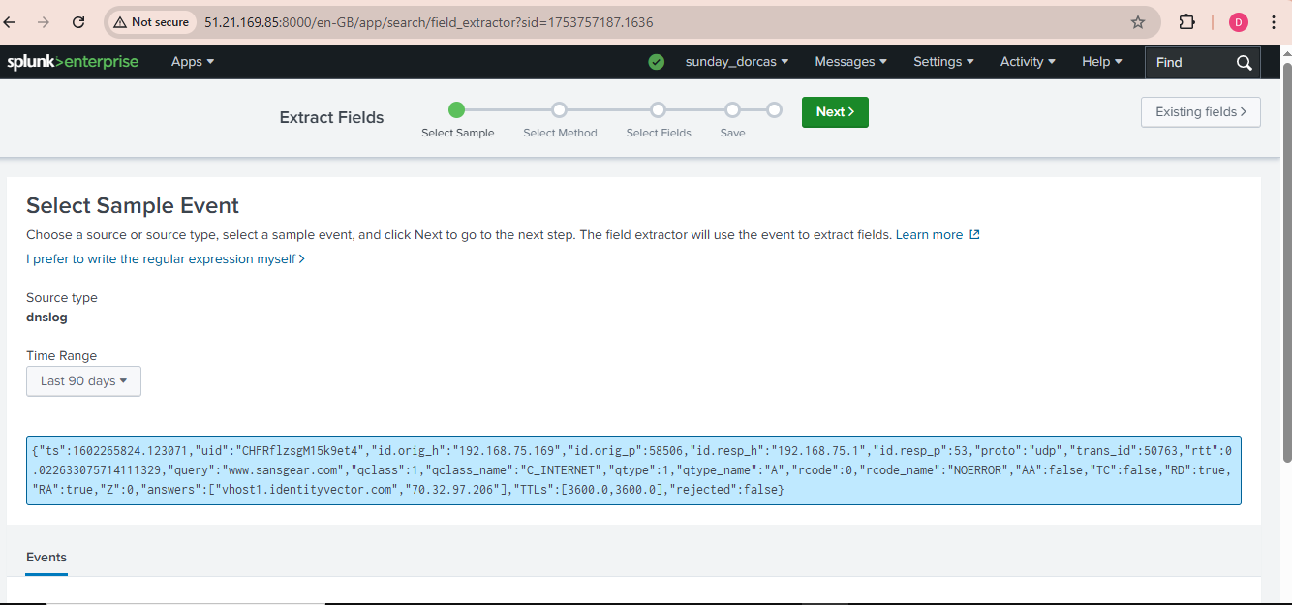

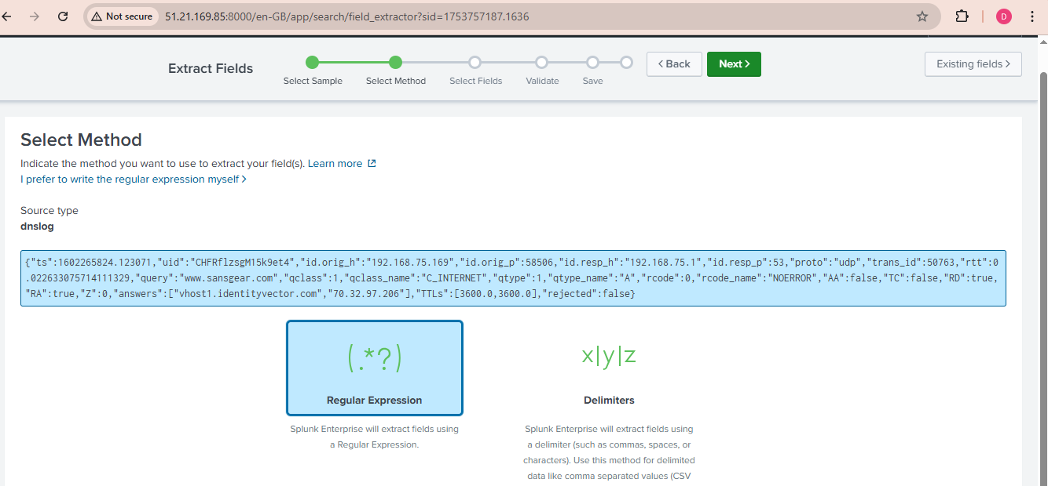

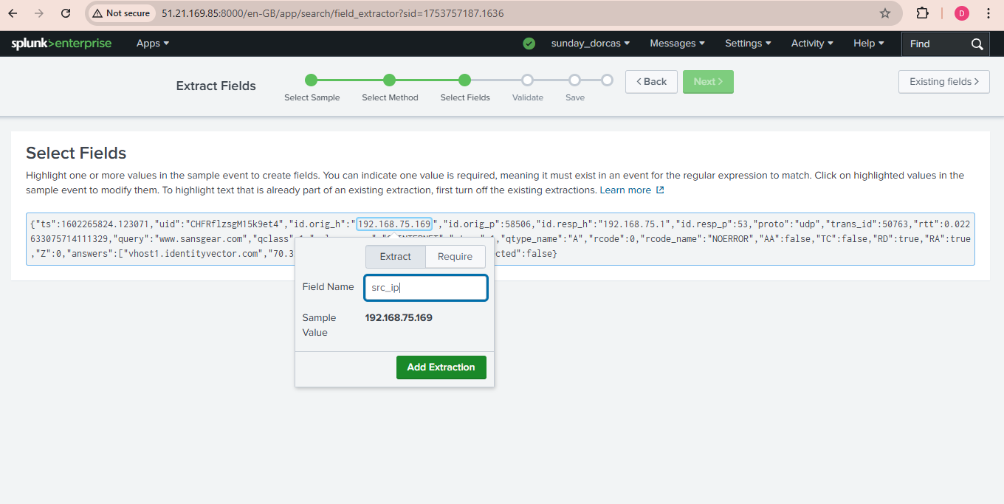

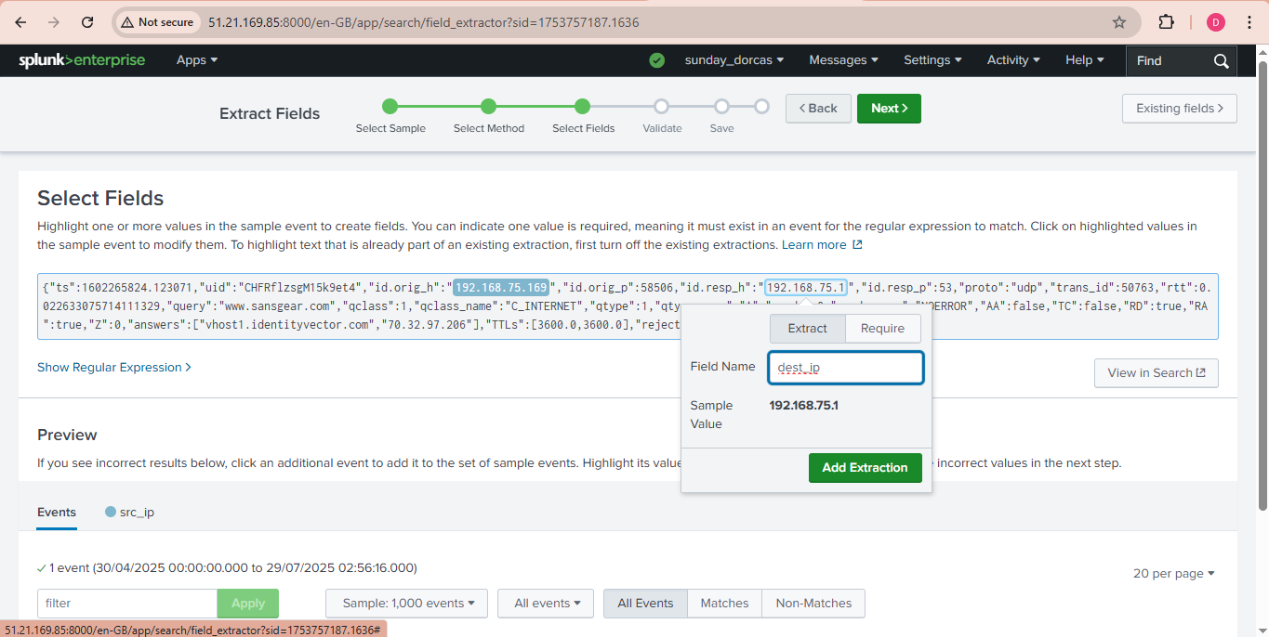

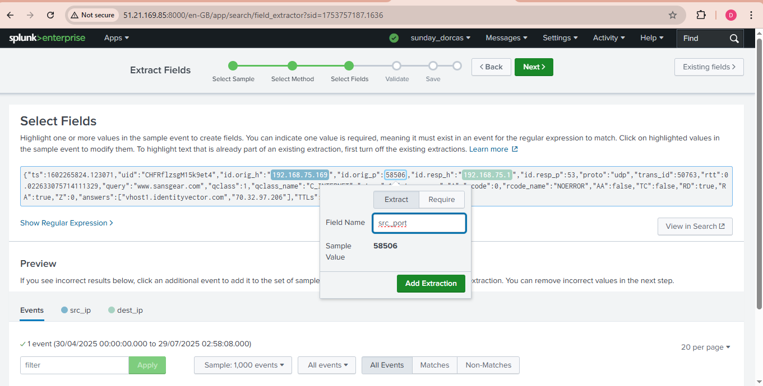

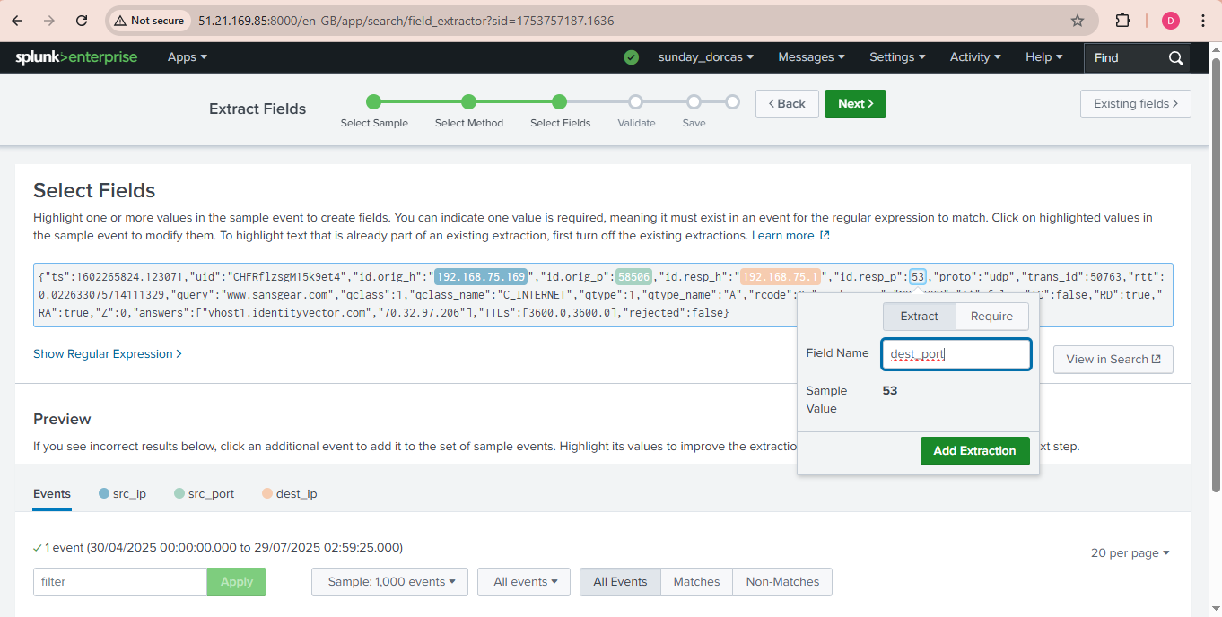

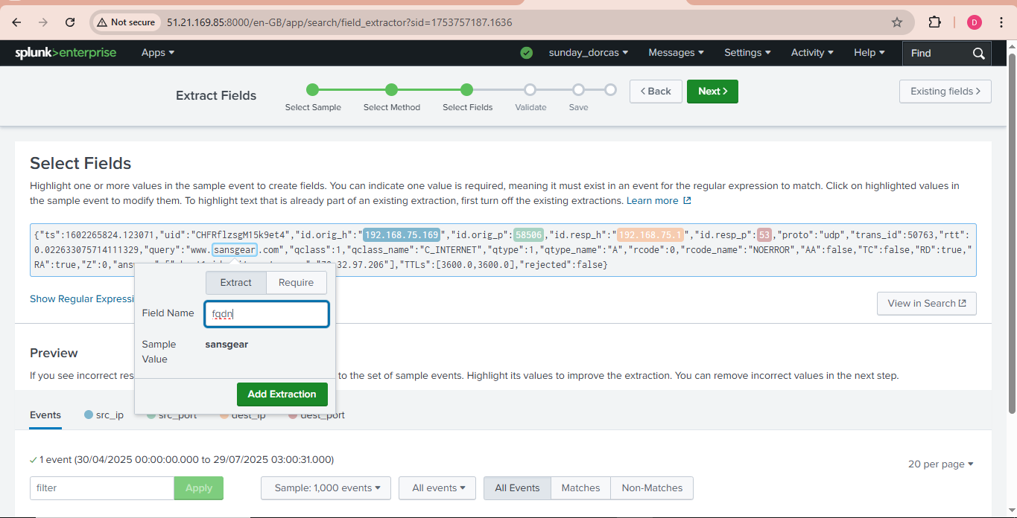

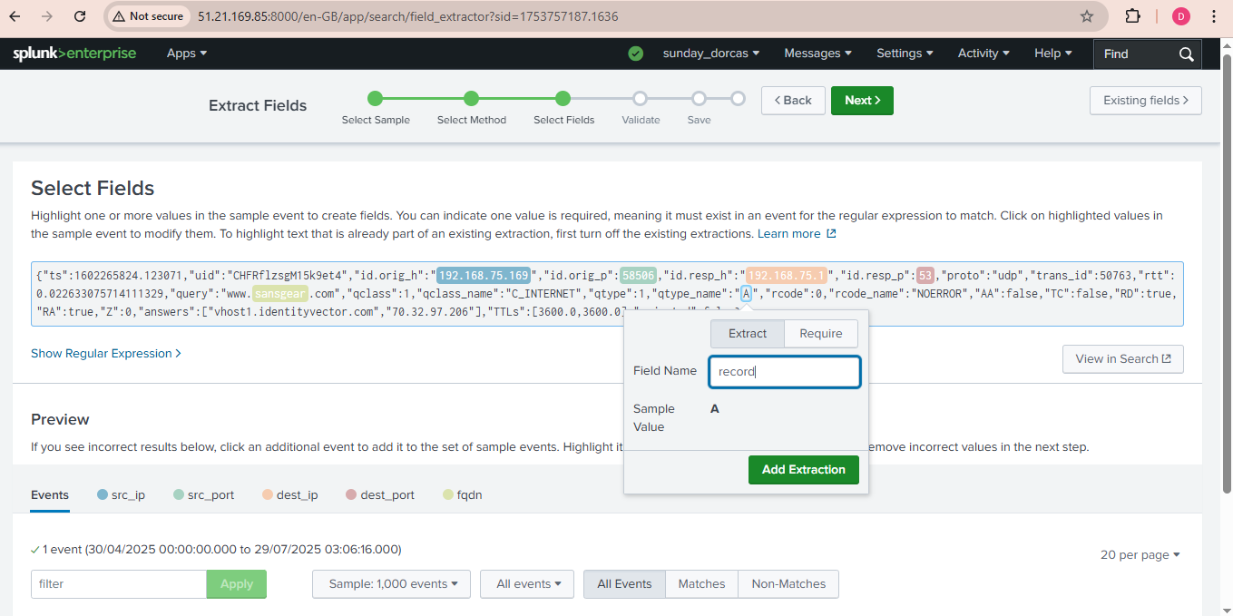

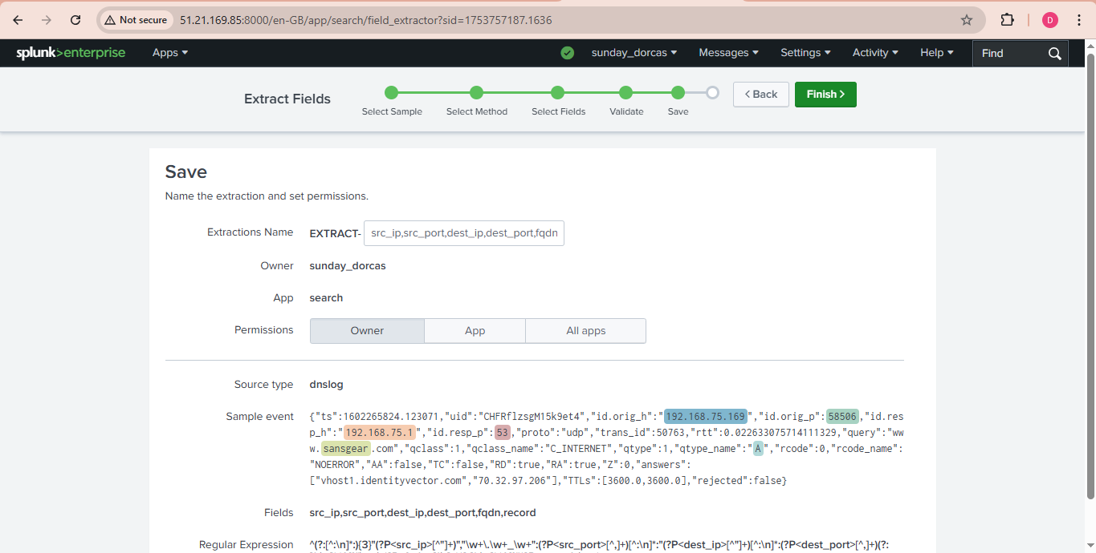

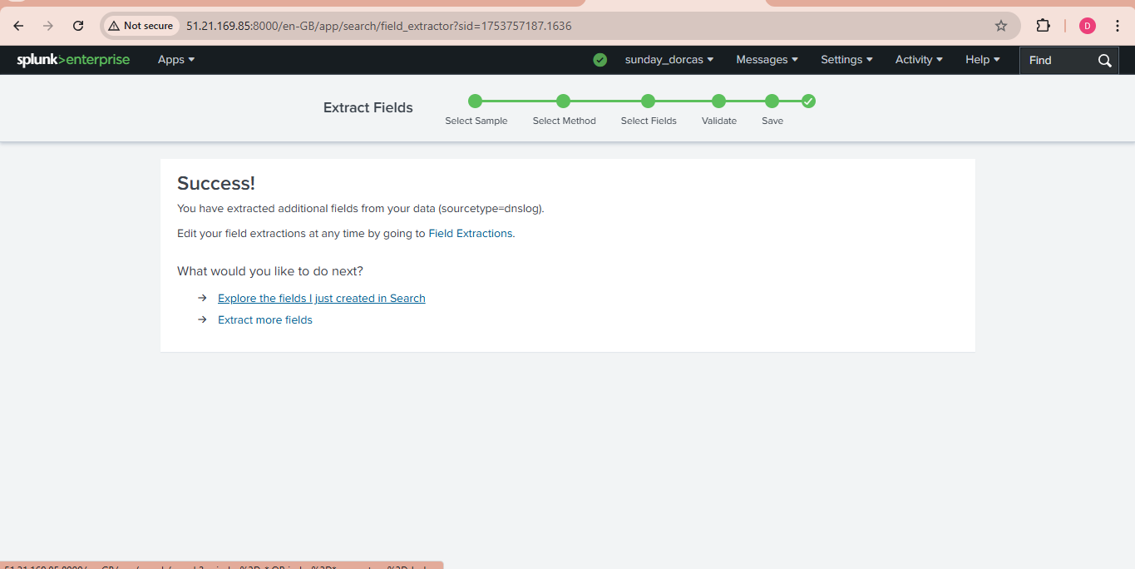

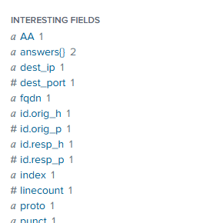

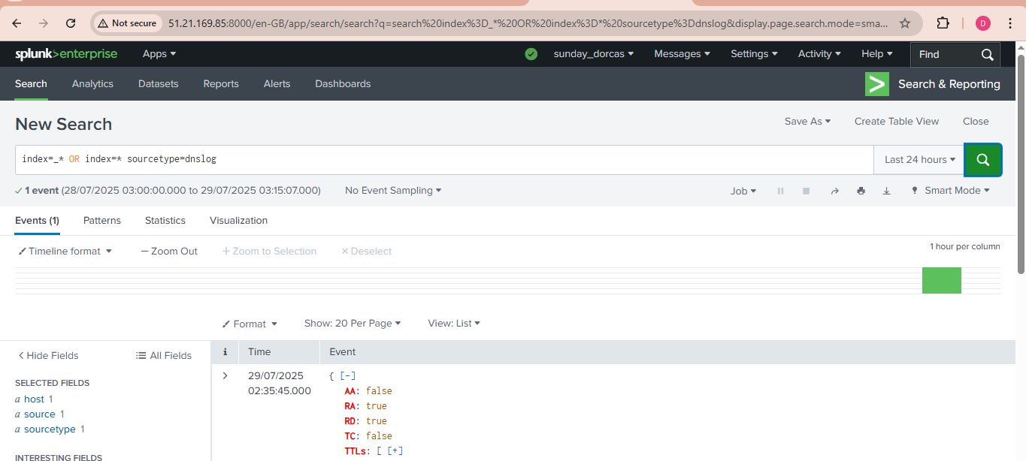
This is the dns event
Index=
index=* sourcetype=dns_sample | regex _raw="(?i)\b(dns|domain|query|response|port 53)\b"
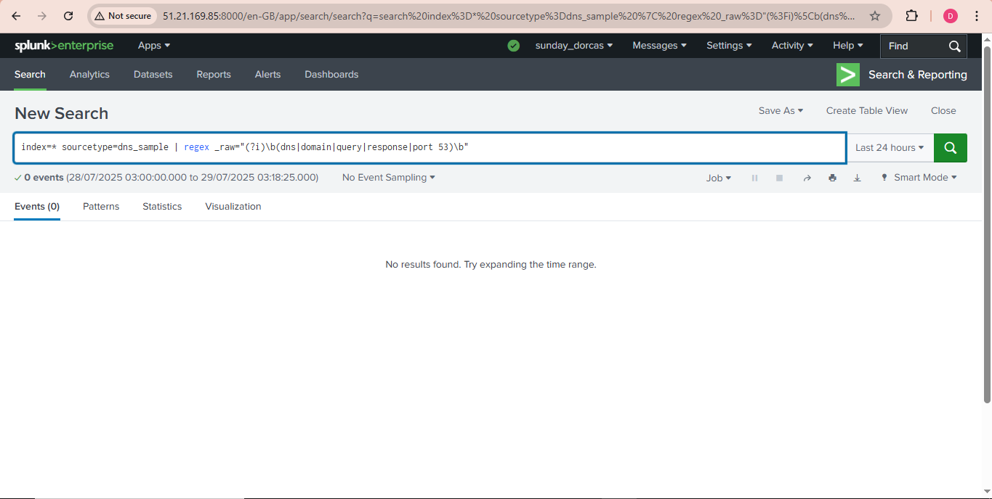

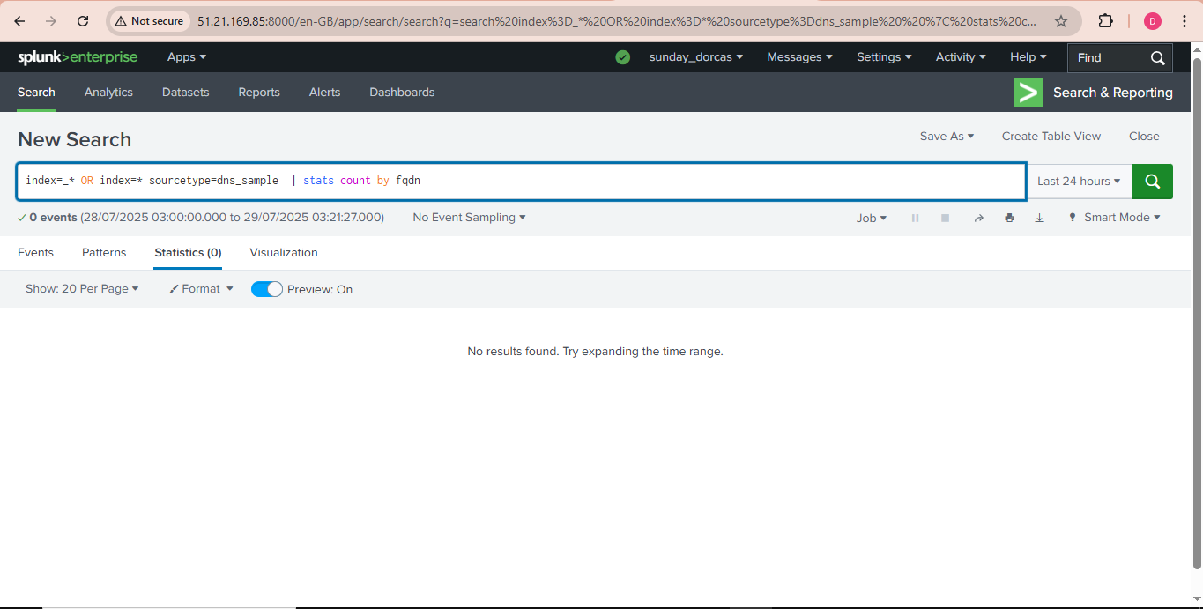
Top dns search did not return any event.
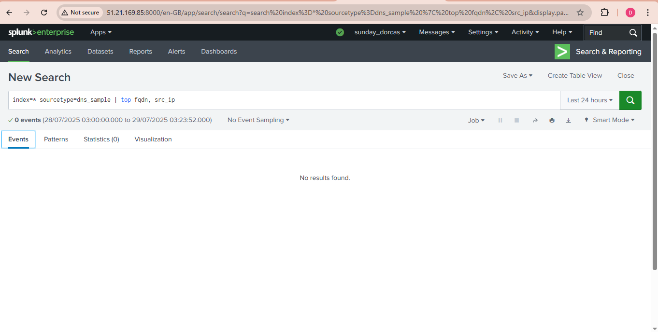
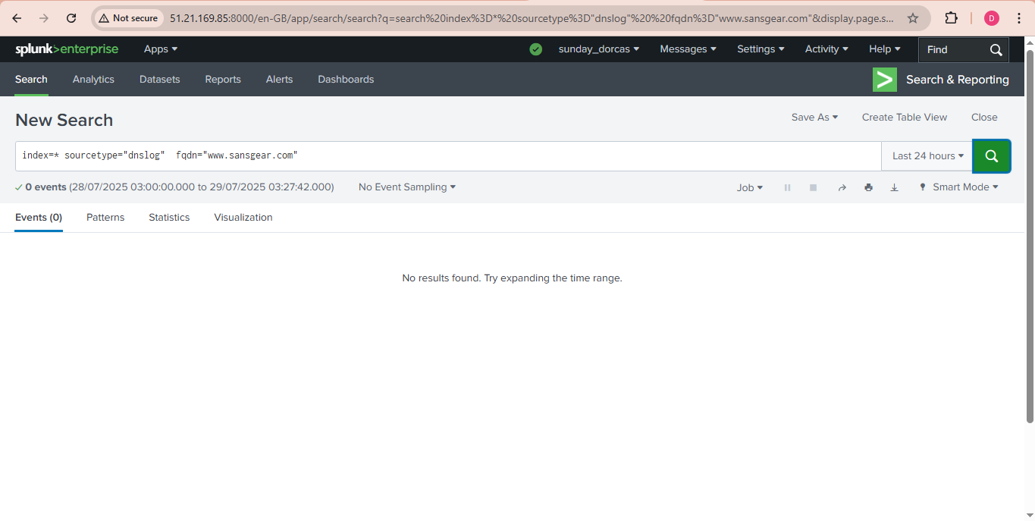

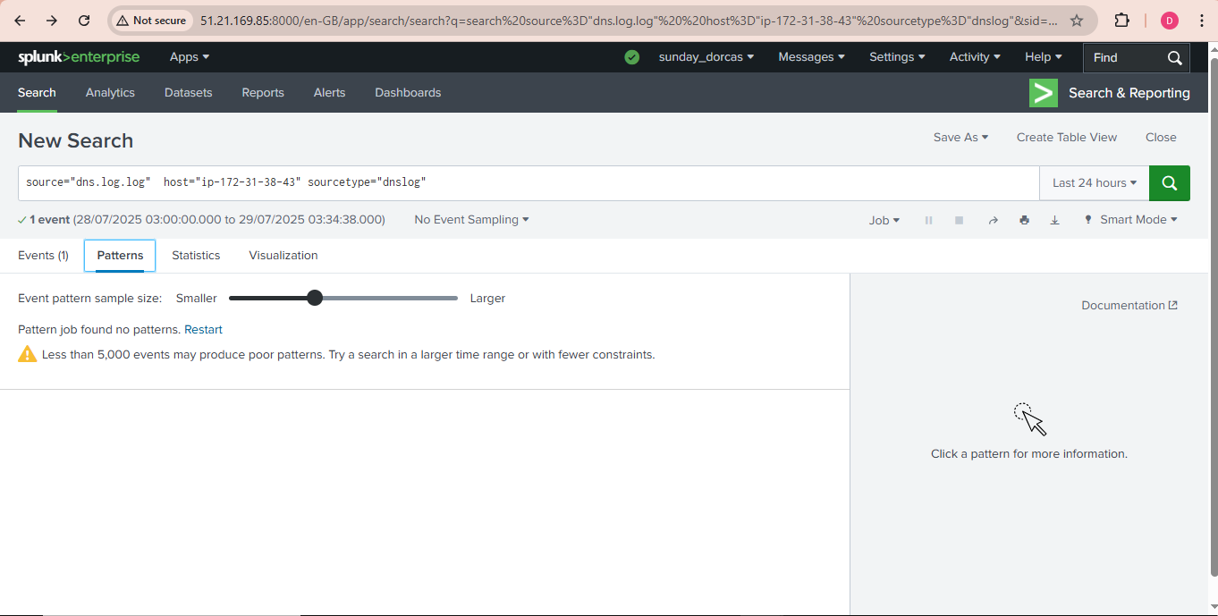

Conclusion
The DNS log file analysis shows an event, further network analysis can be conducted using Wireshark with the sample above.

